National University of Computer and Emerging Sciences



Lab Manual

for

Programming Fundamentals

|  |  |
| --- | --- |
| Course Instructor | Dr. Mubashir Baig |
| Lab Instructor(s) | Mr. Fraz Yousaf  Ms. Samia Akhter |
| Section | PF 1A |
| Semester | Fall 2021 |

Department of Computer Science

FAST-NU, Lahore, Pakistan

# INTRODUCTION

**WHILE LOOP:**

A **while** loop statement repeatedly executes a target statement as long as a given condition is true.

## Syntax

The syntax of a while loop in C++ is −

while(condition) {

statement(s);

}

Here, **statement(s)** may be a single statement or a block of statements. The **condition** may be any expression, and true is any non-zero value. The loop iterates while the condition is true.

When the condition becomes false, program control passes to the line immediately following the loop.

## Flow Diagram

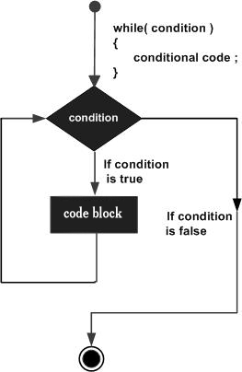

Here, key point of the *while* loop is that the loop might not ever run. When the condition is tested and the result is false, the loop body will be skipped and the first statement after the while loop will be executed.

# Lab Manual 05

**Problem 1:**

Write a functions to print the maximum and the minimum number respectively among three numbers entered by user.

## Problem 2:

Take num as input and determine if it is triangle or not.  
Note: use user defined function and num as a parameter

**Problem 3:**

Write a number to calculate and display the sum of following series using while loop.

x + x2 + x4 + …….. + xn

**Hint:**

Used **pow(x,i)** function for power

**Output:**

Enter a number : 5

Enter a value n : 5

Sum =655

## Problem 4:

Create a calculator that takes a number, a basic math operator (+,-,*,/,^), and a second number all from user input, and have it print the result of the mathematical operation. The mathematical operations should be wrapped inside of functions

**Problem 5:**

Write a program that displays the following using while loop.

**Output:**

4 4 4 4

3 3 3

2 2

1